The Art of Shape-Shifting

August 4th, 5th, and 6th, 2016
Casket Arts Building
681 17th Ave NE, Minneapolis, MN, 55413
Studio 114
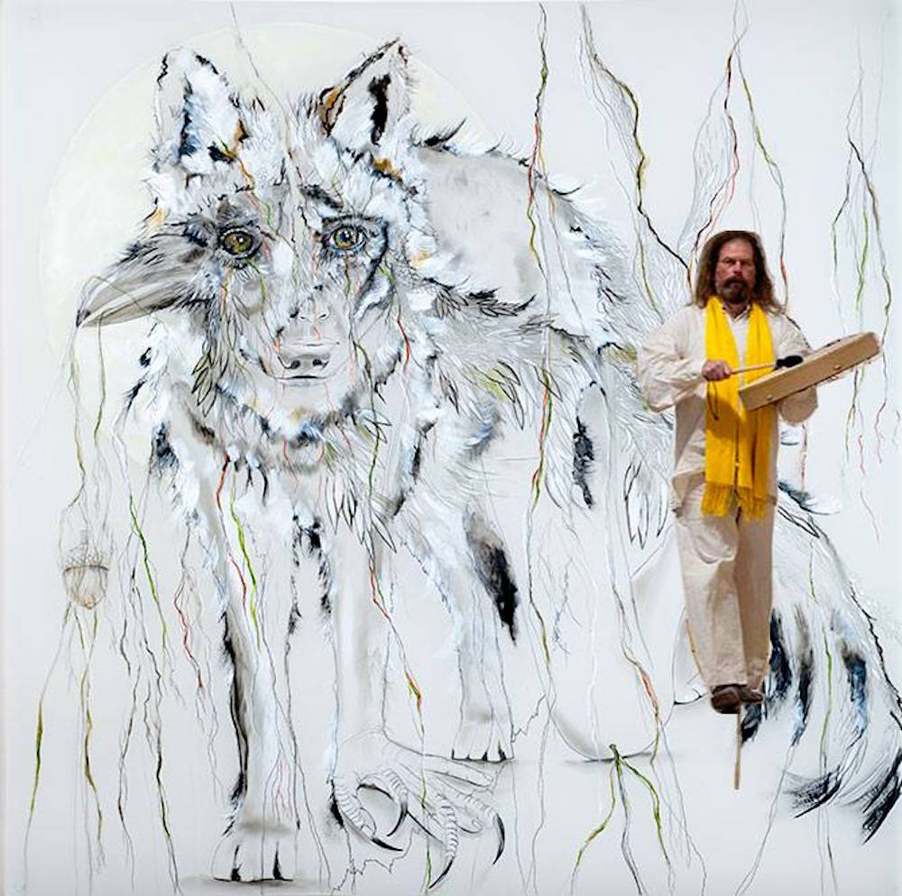
The Art of Shape-Shifting Website: theartofshapeshifting.weebly.com

The Art of Shape-Shifting Events

Open Studio Event
Date: Thursday, August 4th, 2016

Time: 5:00 PM - 10:00 PM

Price: Free
Witness art as it is presented during its most vulnerable, transformative state: during its creation. Barkmeier and Rudy will have work on display, each coexisting and influencing the other. During this time, they will create and shape new visions and sounds. Experience polygenesis as time unfolds and new works blossom in time and space.
Sound Meditation and Visual Journey

Dates: Friday, August 5th, Saturday, August 6th, 2016

Time: Doors at 6:30, Event 7:00 PM - 9:00 PM

Price: $20 in advance, $25 at the door, 40 open spots per night.
Find your inner harmonious balance through a guided sound meditation and visual spirit journey. This healing, multi-sensory experience is led by Rudy influenced by interactions with the energies Barkmeier’s of imagery in her Casket Arts studio space. Following these journeys, light hors d'oeuvres will be served during community gathering and integration of this experience.
Tickets: Sound Meditation RSVP

Private Guided Meditation and Spiritual Healing
Dates: Friday, August 5th, Saturday, August 6th, 2016

Times Available: 1:30 – 2:30 PM, 3:00 – 4:00 PM.

Price: $100 Per Private Session
Private individual sessions are available to those wishing to pursue a more personalized meditation and spiritual healing. You can lie comfortably on a massage table and bathe in an intuitive sound stream initiated by your own intention and the energies that you want to work with. You will experience a journey of your own making through the collaborative sounds orchestrated by our collective higher intelligences.
Tickets: Private Session RSVP

Healing Through Art and Sound
Local Artist Paula Barkmeier has invited Composer/Sound Practitioner, Dr. Paul Rudy, from Kansas City, to play, collaborate and improvise in the art of shape-shifting with image and sound in her Casket Arts studio. Both artists work with the medicine of the in-between dimensions, where one form transmutes and transforms into another in coexistence. In Barkmeier’s work, animals and humans share elements; one emerging out of the other in a transmutation that masks which originates and which follows. Rudy’s amorphous sound work shape-shifts through the identifiable to the indescribable. Sounds from the every day world become music and vise-versa. In both artists’ creative process, origins and boundaries become fluid and forms from the Dreamworld of the Great Mystery manifest through a thin veil.

Many decades ago, Edger Cayce said that sound is the medicine of the future. In many cultures, sound is medicine. It is a medium that carries healing power into the mind, body and spirit. On the Friday and Saturday following the Thursday Open Studio event, both group and private sessions of guided mediations and are offered to provide the subconscious a gateway into a spiritual journey that will offer intuitive healing and energetic cleansing.

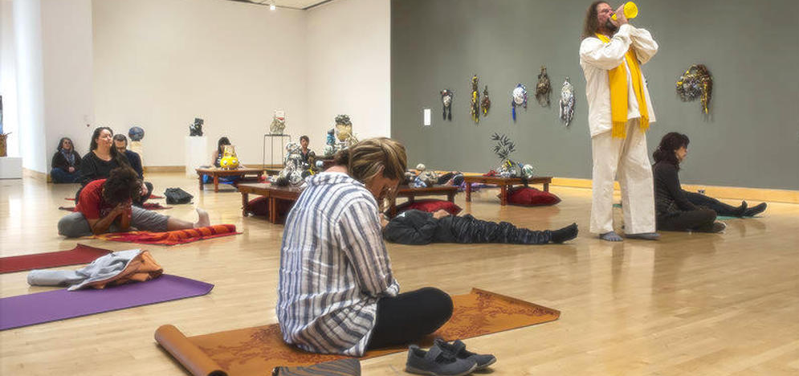
Musician and composer Paul Rudy projects his voice through a toy megaphone as he walks among the meditating crowd at the Kemper Museum of Contemporary Art.
JULIE DENESHA / KCUR 89.3FM

About The Artists
Paul Rudy

Rudy’s music has been described as “the Universe unfolding one sound at a time” and “a lifetime compressed into a hour.” He takes his participants on a sound journey, from earth to sky, that allows you to tap into both your primordial and celestial selves. Recognizable and transformed sounds allow one to engage and integrate mind, memory and body. Prepare to take a journey where your inner meets your outer and the universe within connects with the great beyond as all parts of us harmonize.

Artist’s Statement:
My music is made up of sounds from around the globe. The sounds I use traverse a distance from recognized and obvious, to eclipsed and highly altered and transformed. They are engaged for their beauty as well as their emotional content, and especially for a sonic residue that remains especially in digital capture. I place them in a context that maximizes mental, spatial, temporal, emotional, physical, and spiritual resonance. Transformation of sounds encourages an excursion into the hinterlands of each individual memory and imagination that chooses to partake. There is no attempt to fuse a narrative, but rather to create a landscape where you can trek at will, and pursue the pathways of your own instinct; re-writing your story, and perhaps even bumping into another yourself along the way.
The sound I make and channel is a creation story: not the ones gone by, but rather the one of our bright present, and our potent future. It listens to intuitive intelligence beyond what is known, and sings from ancient cosmology. It is music about the coming-of-age of our planet, and a growing consciousness that resonates inward to each individual at whatever stage along their path of enlightenment. It reverberates outward towards our universe where all entangles, bathed in resonant energy and nourished by harmonic convergence.

Rudy’s Website: paulrudy.com

Paula Barkmeier

Barkmeier’s imagery has been described as “the empathic connection between nature and man” and “the visualization of the cries of Mother Earth”. She vividly portrays the spiritual connection between the natural world and humanity. Her artwork reinforces the philosophy of interconnection in all things, reminding us of where we come from and where we once again will return. “The Earth does not belong to us, but that we belong to the Earth.” With tangible emotions emitting from the mylar, to experience her art is to experience yourself.

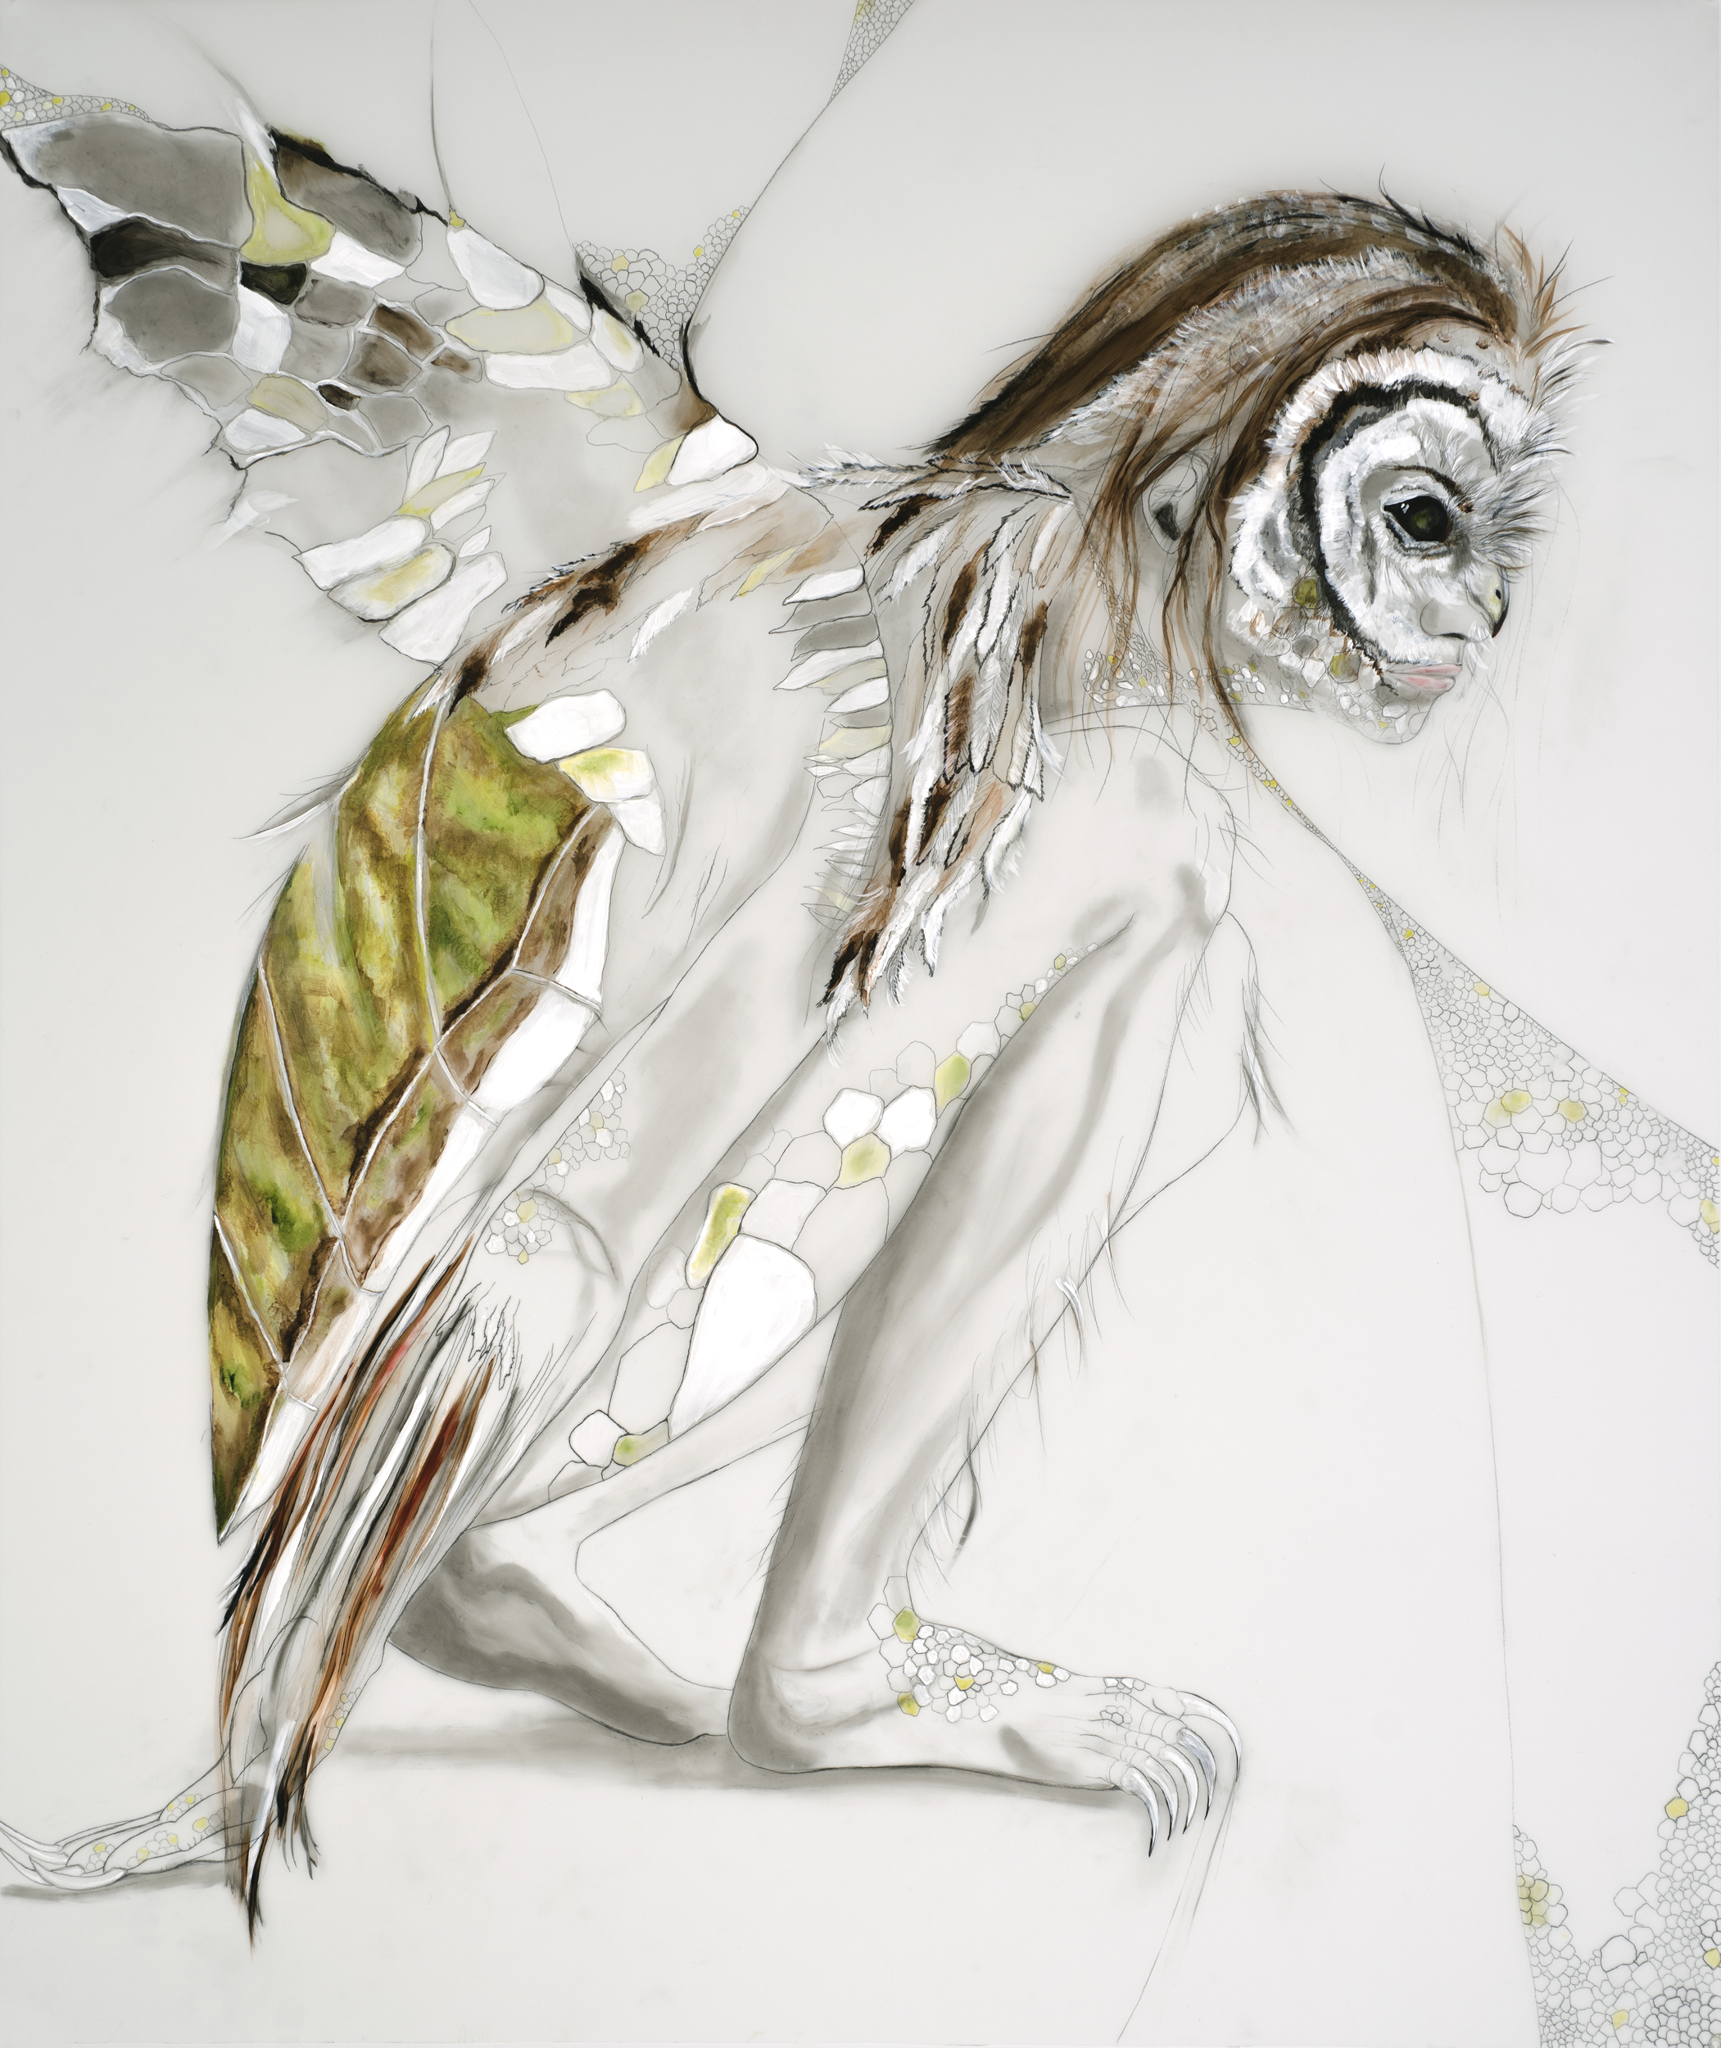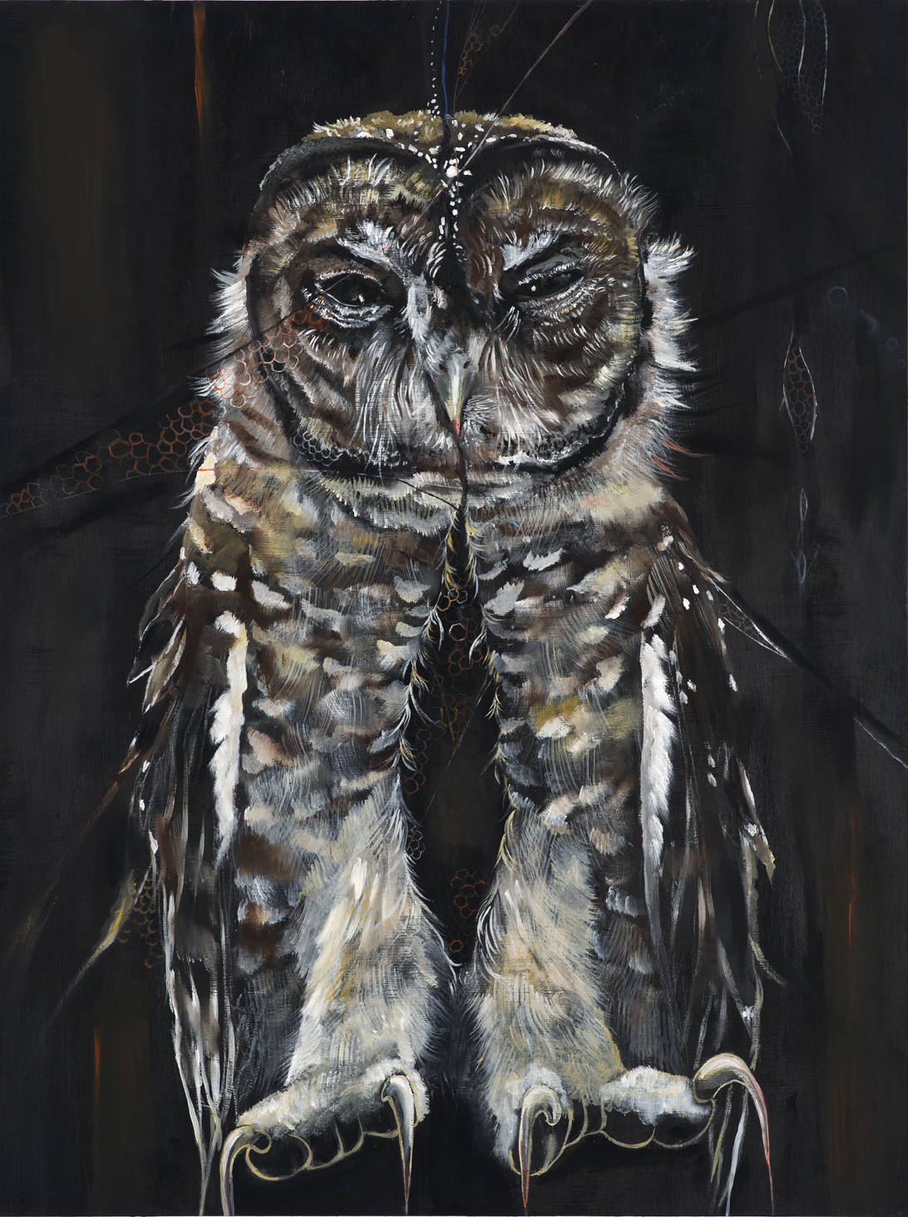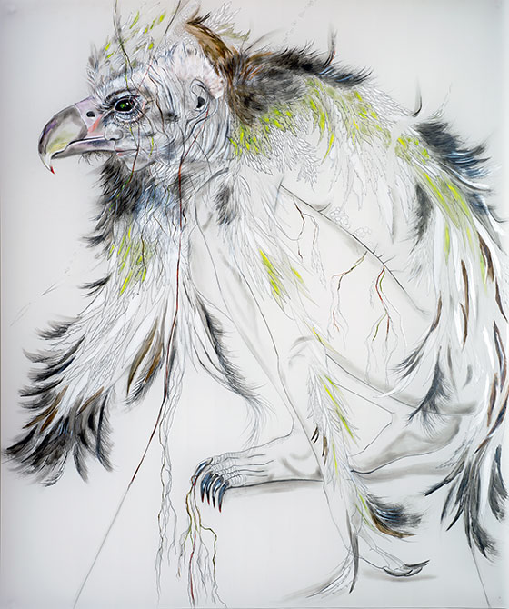

Artist’s Statement:
Within every one of us there is a wild and natural creature, a powerful force of instinctual and creative being. My work speaks of a longing for wildness. Opposing forces of dark and light find their place.
The creatures inhabiting my installations are hybrids of real entities in nature and imaginary forms. Different perceptions of reality are questioned. Where do animal and human meet? Human and animal parts morph to form new species. Boundaries between the conscious and unconscious realms are blurred. One is invited to question the relationships between these creatures, and how they interact with us in our dreams, psyche, and everyday existence.

Barkmeier’s Website: paulabarkmeierart.com

